Business Intelligence

Miss Abeera Tariq, Spring 2025

# Spot the BI Assignment

### Members

1. Farah Inayat - 26912
2. Hamna Inam Abro - 27113
3. Zehra Ahmed - 26965
4. Zuha Aqib - 26106

# Table of Contents

Spot the BI Assignment 1

Members 1

Table of Contents 1

Task 1 3

**FoodPanda 3**

Personalized Recommendations 5

Search Filters and Sorting Options 7

Product Dashboards (reviews, ratings) 10

Dynamic Pricing and Promotions 12

Others 14

**SAYA** 15

Personalized Recommendations 15

Search Filters & Sorting Options 18

Product Dashboards 20

Dynamic Pricing and Promotions 21

Inventory Indicators 22

Others 23

Task 2 24

**FoodPanda** 24

**Saya** 26

**Overall benefits of having BI** 27

Task 3 28

**FOODPANDA** 28

Why are these recommendations shown to customers? 28

How does the system know when to send notifications? 29

What types of data are collected by the platform? 29

Why do prices change dynamically? 30

**SAYA** 31

Why are these recommendations shown to customers in Saya Clothing? 31

How does the system know when to send notifications? 32

What types of data are collected by the platform? 32

Why do prices change dynamically? 33

# Task 1

Visit two online stores of different types (e.g., Amazon, Daraz, Foodpanda, Imtiaz, Naheed, or any other e-commerce site) with at least one also having a physical presence.

Identify and document the following BI elements:

## FoodPanda

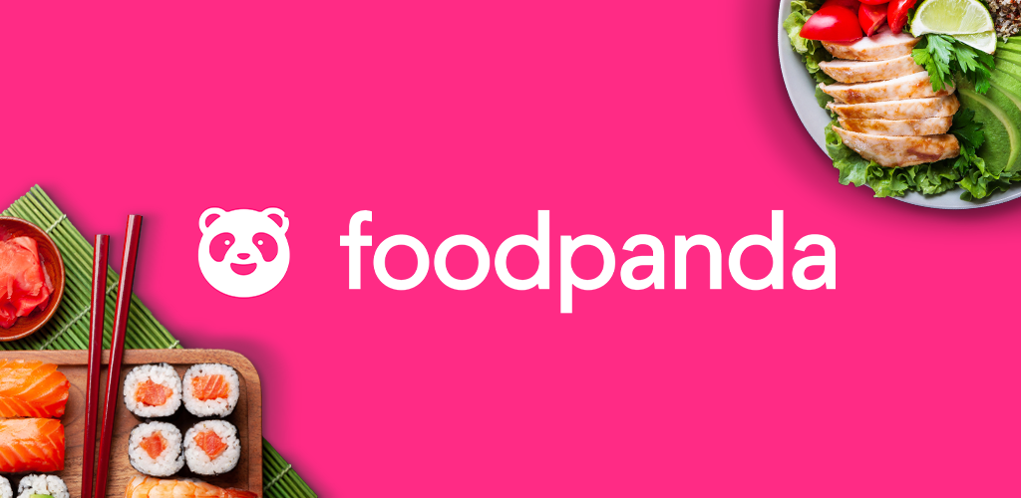

**User Interface**

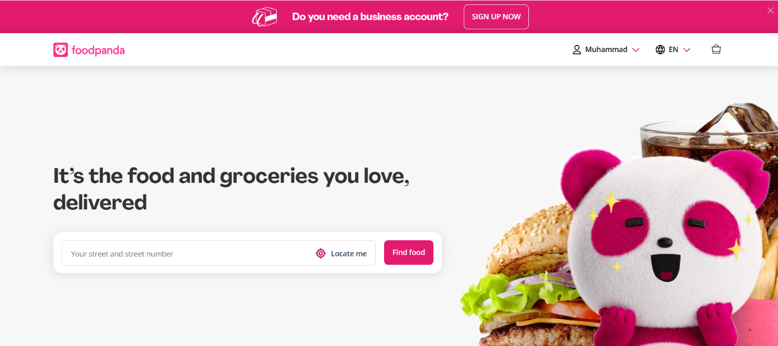

**Time Data Intelligence** adjusts deals and promotions based on the time of day, such as offering exclusive nighttime discounts, enhancing user engagement and sales.

leverages **Location Intelligence** to display nearby restaurants and relevant options based on the user’s current location, ensuring convenience and faster deliveries.

1. **Clean and Modern Design**
   1. Foodpanda's interface features a sleek, visually appealing layout with a modern color scheme of pink and white, making it easy on the eyes and enhancing user engagement.
2. **User-Friendly Navigation**
   1. The app is designed for a seamless experience, with intuitive icons, a well-organized menu, and smooth transitions, ensuring users can easily browse and place orders without confusion.
3. **Visually Attractive and Engaging**
   1. High-quality images of food, restaurant logos, and neatly arranged categories make the UI visually appealing, enticing users to explore more options and increasing order likelihood.

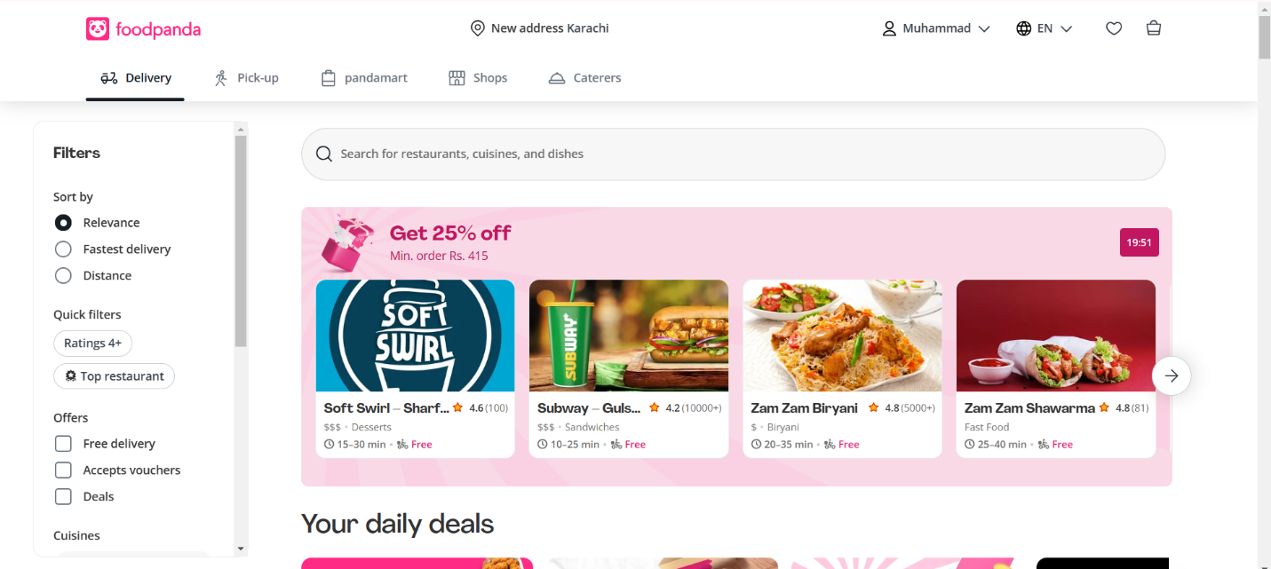

After entering in our location, it showed deals and offers according to what was near me

### Personalized Recommendations

**Frequently Ordered Together**

utilizes the feature by analyzing past order data to identify popular item pairings, encouraging customers to add complementary products to their cart.

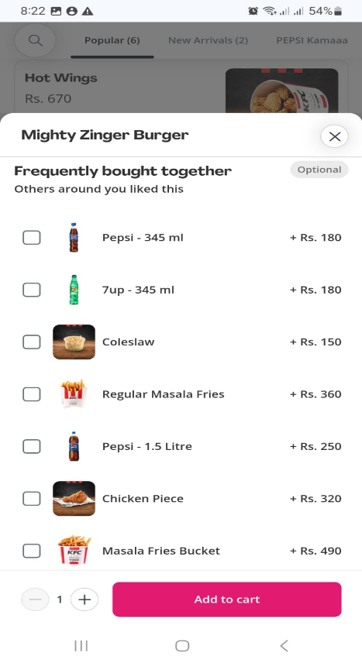

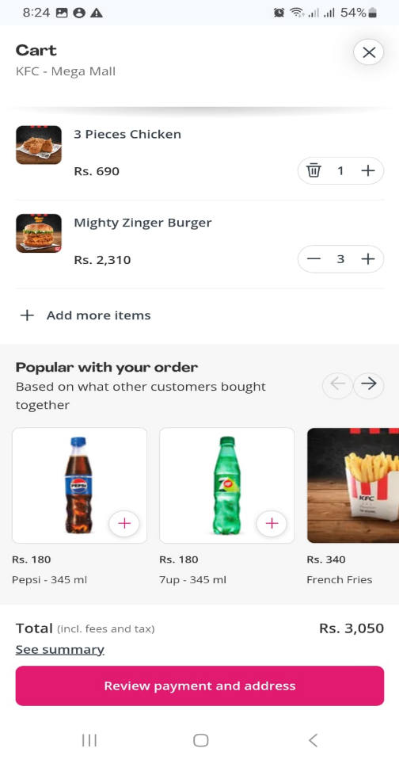

**You May Also Like**

leverages recommendation algorithms to suggest items based on user preferences, browsing history, and trending dishes, ultimately increasing order value and enhancing user experience.

1. **Recently Viewed –** 
   1. Foodpanda remembers the restaurants and dishes a user has recently checked, allowing for quick reordering and a more seamless browsing experience.
2. **Trending & Seasonal Recommendations –** 
   1. The app highlights Cricket Deals, Iftar Specials, and Winter Comfort Food, using seasonal trends and demand forecasting to promote relevant offers.
3. **Past Orders & Reordering –** 
   1. Users can easily reorder their favorite meals from past purchases, reducing friction and making the ordering process faster.
4. **Brand Collaborations –** 
   1. Foodpanda partners with brands like Pepsi, Nestlé, and Coca-Cola to offer exclusive bundle deals, increasing order value and customer engagement.
5. **Cuisine Categories –** 
   1. The app segments restaurants into cuisines (Desi, Fast Food, Chinese, etc.), making it easier for users to filter and find their preferred dishes.
6. **Menu Optimization for Restaurants –** 
   1. Foodpanda analyzes sales data to suggest menu changes to restaurants, helping them optimize their offerings by keeping bestsellers, removing underperforming dishes, or introducing new bundles.
7. **Regional Demand-Based Suggestions –** 
   1. If Biryani sells 30% more in Karachi than in Lahore, Foodpanda recommends Karachi-based restaurants highlight Biryani prominently, ensuring localized menu optimization.
8. **Churn Prediction ("We Miss You" Vouchers) –** 
   1. The platform detects inactive users and sends personalized discount vouchers via email or app notifications to encourage them to place orders again.

### Search Filters and Sorting Options

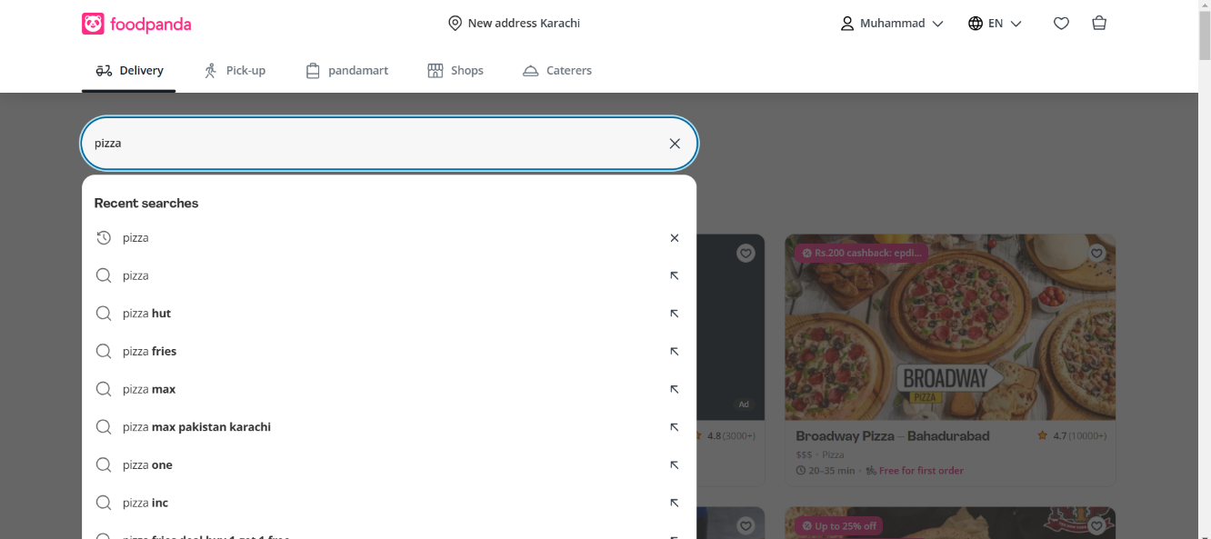

**Intelligent Search Suggestions**

Search system utilizes predictive text and past user behavior to provide real-time suggestions when searching for items like "pizza," making the process faster and more intuitive.

AI-Powered Best Match Sorting based on popularity, delivery time, and order history

**Category-Based Filtering**

The platform allows users to apply category filters, such as selecting "Pizza," to refine search results and display only relevant restaurants, improving search accuracy and user convenience.

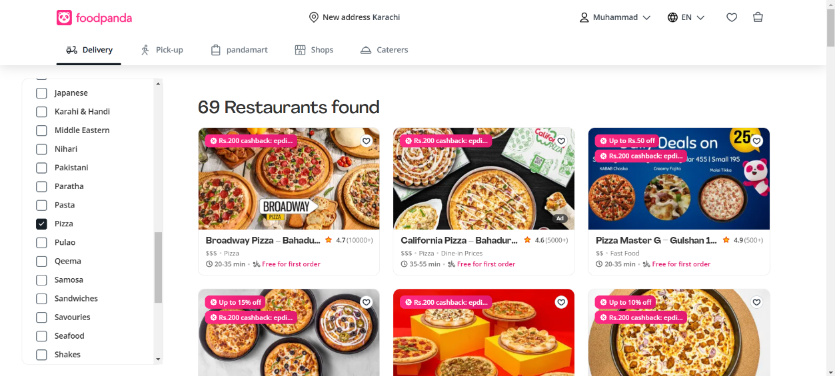

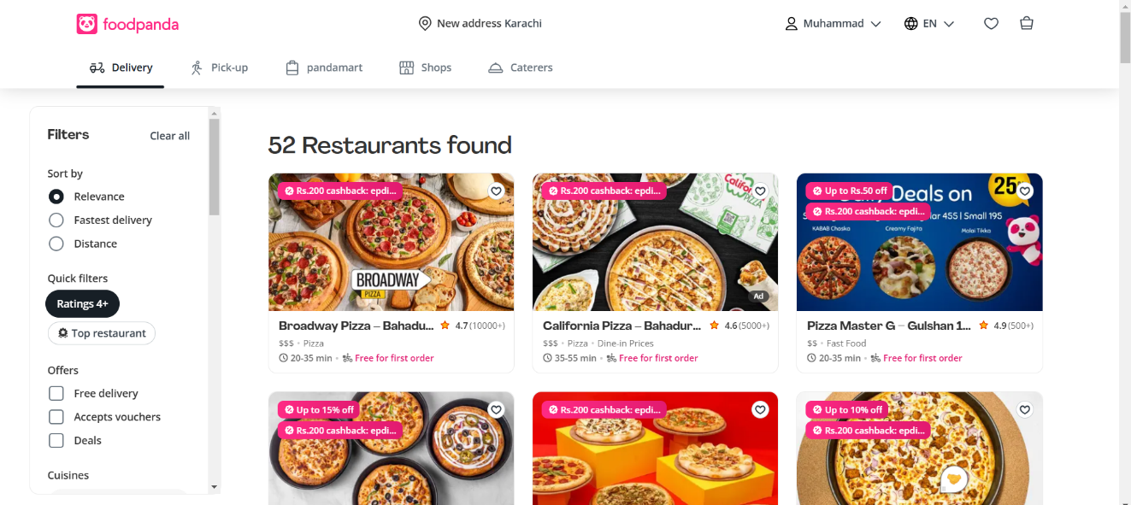

**Customer Ratings Intelligence**

By applying the ratings filter, users can prioritize highly-rated restaurants, leveraging past customer reviews and satisfaction scores to make informed dining decisions.

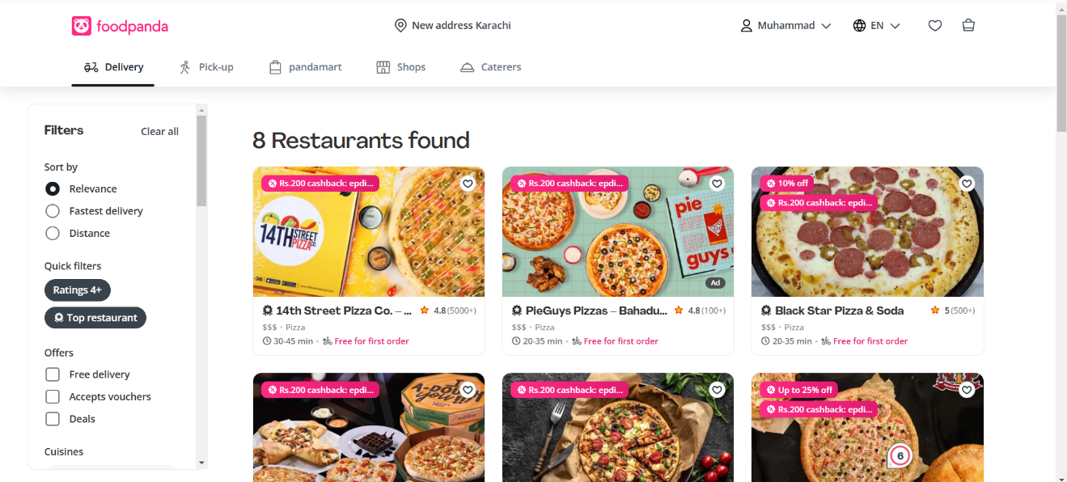

**Top Restaurants Ranking**

Foodpanda highlights top-rated and most-ordered-from restaurants based on user reviews, order frequency, and popularity, providing users with quality recommendations.

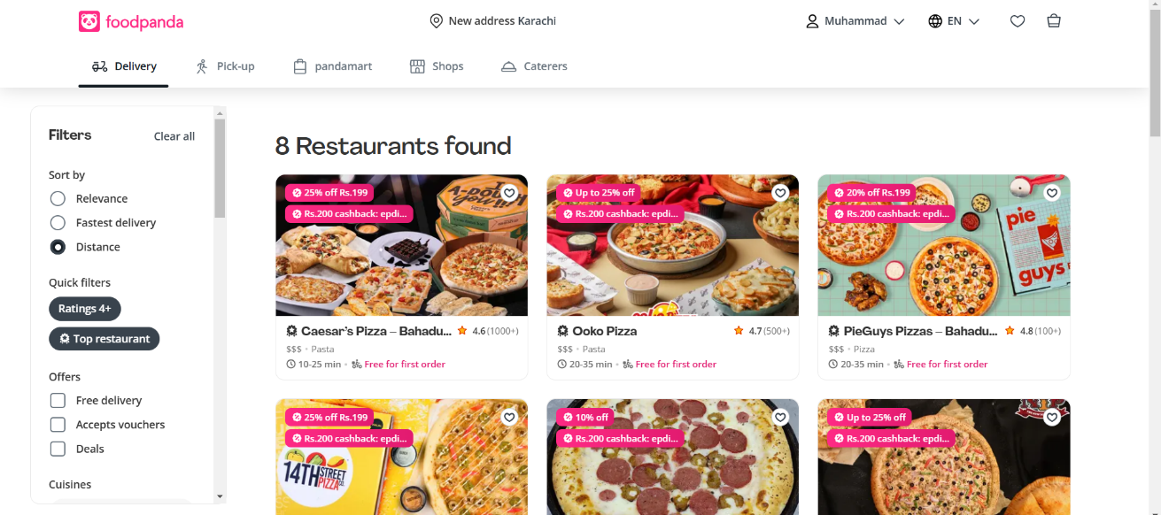

**Distance-Based Sorting**

The sorting feature arranges restaurants by proximity, allowing users to prioritize closer options for quicker deliveries, optimizing the ordering experience.

### Product Dashboards (reviews, ratings)

**Customer Sentiment Analysis**

The rating system (4.6★ from 1000+ reviews) aggregates user feedback to provide a quick restaurant performance overview, using BI to detect patterns in customer satisfaction.

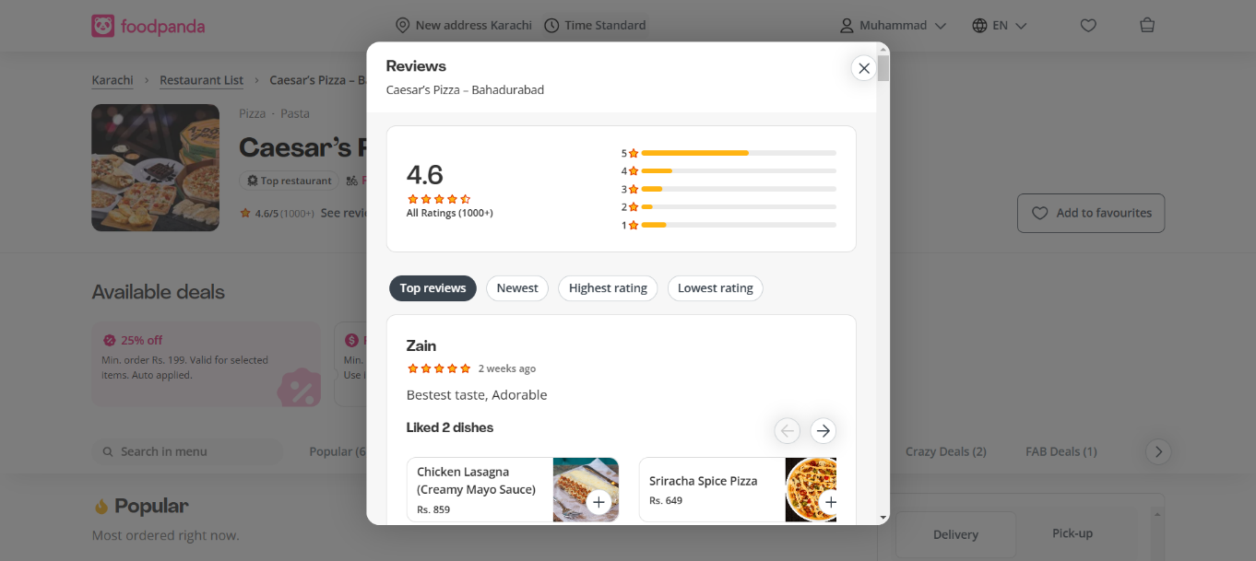

**Verified Ratings for Trust**

The platform ensures credibility by displaying a large number of reviews, reducing bias and increasing transparency, which helps users make data-driven choices.

Popular products vary from location to location for each restaurant (even across branches)

**Review-Based Decision Making**

Users can access detailed reviews to assess food quality, delivery speed, and service, helping Foodpanda refine its recommendations and businesses improve their offerings.

1. **Panda Pro Membership –** 
   1. A subscription model that offers free deliveries, discounts, and exclusive deals, incentivizing frequent users to stay engaged.
2. **Gamification ("Order X More for a Bonus") –** 
   1. The app sometimes encourages users to add more items to unlock special discounts or free delivery, increasing order value.
3. **Preferred Payment Method Suggestion –** 
   1. The system remembers past payment preferences (Cash, Card, Wallet) and suggests the most frequently used one for faster checkout.
4. **Store-Specific Availability –** 
   1. Some items may be available in specific branches only, ensuring users see real-time stock availability based on location.
5. **Estimated Delivery Time –** 
   1. The platform predicts delivery time based on order volume, restaurant prep time, and rider availability, enhancing transparency.
6. **Real-Time Order Status & Live Tracking –** 
   1. Users get real-time updates on their order progress, from preparation to dispatch and delivery tracking, improving customer satisfaction.

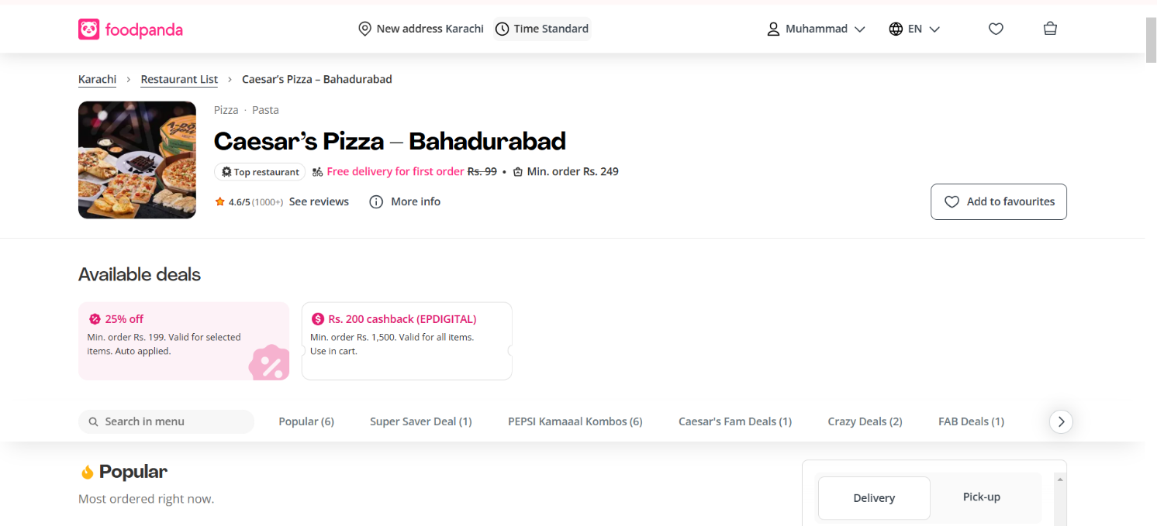

**Search & Category Filtering**

The presence of a "Search in menu" option allows users to quickly find specific items, while categorized deals like "Super Saver Deal" and "Crazy Deals" improve discoverability and streamline decision-making.

**User Engagement Metrics**

The "Popular" section showcases frequently ordered items, leveraging order data and trends to recommend bestsellers, increasing the likelihood of users choosing high-demand items.

**Personalized Promotions & Deals**

The dashboard displays available discounts, cashback offers, and exclusive deals, which are dynamically adjusted based on location, time, and user preferences to encourage purchases**.**

**Restaurant Ranking & Quality Indicators**

The "Top restaurant" badge and rating (4.6/5) help users make informed decisions by highlighting high-quality and popular restaurants based on customer feedback and order frequency.

### Dynamic Pricing and Promotions

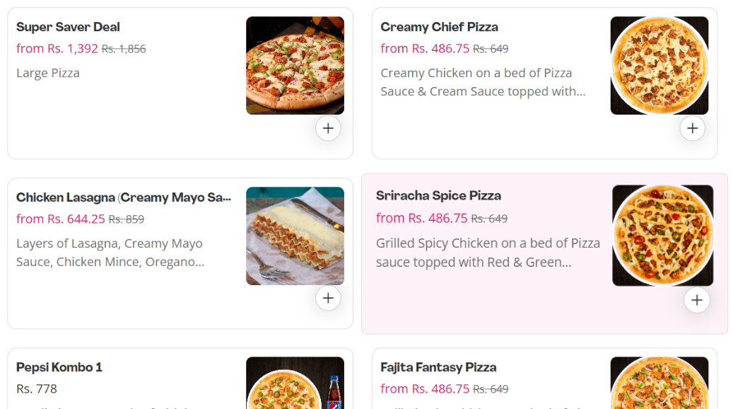

**Most Sold Items Promotions**

Foodpanda highlights popular and frequently ordered dishes in the "Popular" section, using sales data to recommend bestsellers. This BI-driven feature increases conversions by promoting high-demand items that customers are more likely to order.

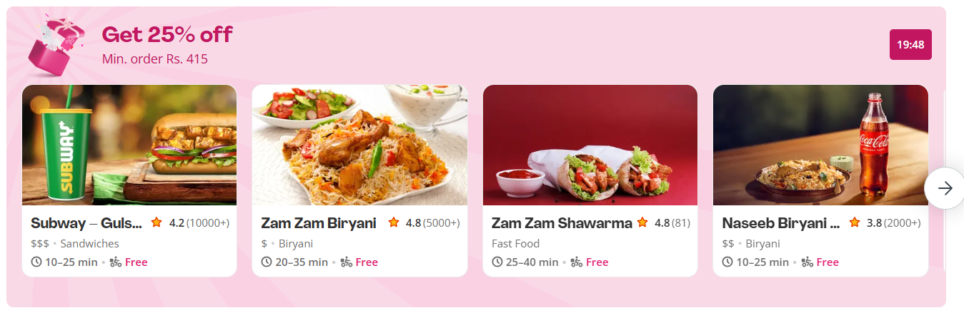

1. **Real-Time Price Adjustments –** 
   1. Delivery charges fluctuate based on demand, weather, and restaurant popularity (e.g., during rain or peak hours, delivery fees increase).
2. **New vs Returning User Vouchers –** 
   1. First-time users often receive discounted deals, while returning customers get loyalty-based promotions, ensuring tailored engagement.
3. **Price Drop Alerts & Notifications –** 
   1. If a restaurant, like McDonald's, drops the price of a Chicken Burger by 15%, Foodpanda may notify competing brands to adjust their pricing dynamically.
4. **Foodpanda Special Combos/Discounts –** 
   1. Exclusive meal combos and limited-time discounts are designed to encourage larger orders and increase customer retention.

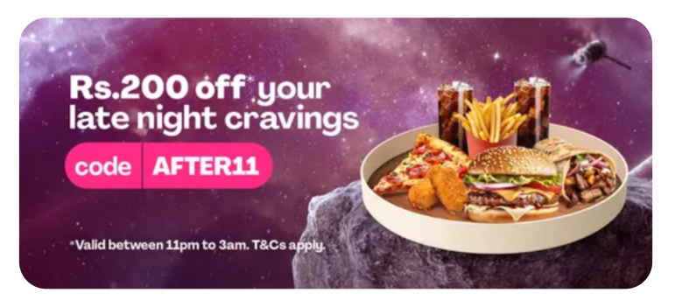

**Time-Based Promotions**

The platform offers dynamic time-sensitive deals, such as Midnight Deals, Lunch Discounts, and Happy Hour Offers, tailoring promotions based on customer demand patterns throughout the day to maximize engagement and sales.

**Limited-Time Indicators**

Promotions often come with a time limit (e.g., "Valid from 12 AM - 3 AM") to create urgency and encourage faster decision-making. These BI-powered flash sales use behavioral data to optimize discount timings for peak ordering periods.

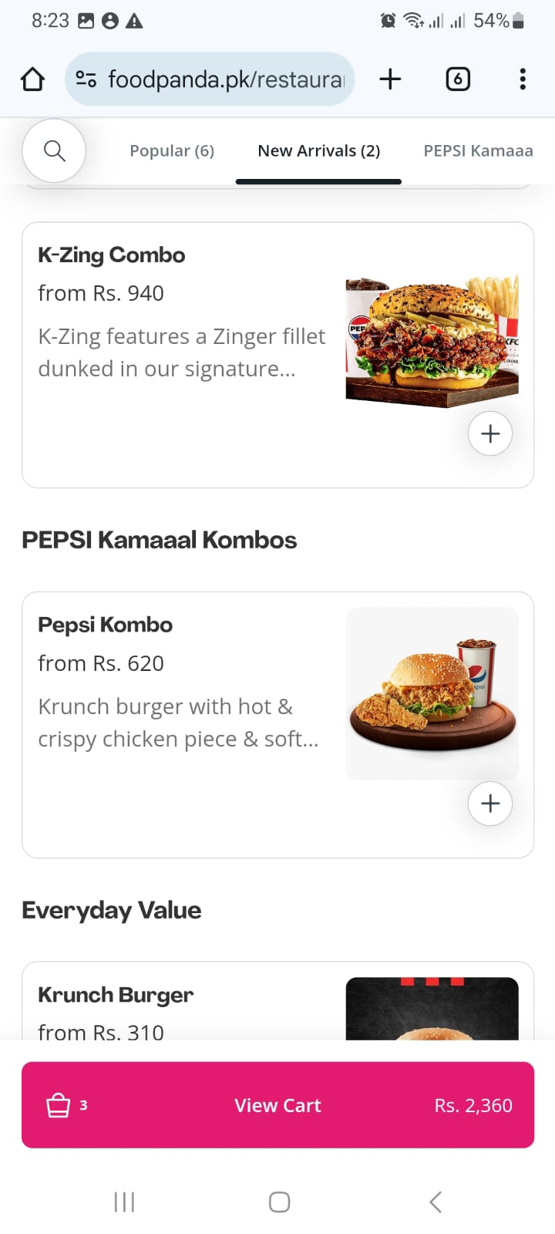

**Brand Collaborations**

Foodpanda partners with brands like Pepsi, Nestlé, and Coca-Cola to offer exclusive bundle deals, increasing order value and customer engagement.

### Others

1. **Optimized Delivery Zones –** 
   1. AI determines which restaurants can deliver to specific areas while ensuring fastest delivery times, optimizing logistics.
2. **Demand Forecasting for Restaurant Expansion –** 
   1. Foodpanda uses order data to help restaurant partners decide where to open new outlets based on high-demand locations.
3. **Cloud Kitchen Optimization –** 
   1. The app identifies high-demand areas and suggests new virtual kitchens for delivery-only restaurants, reducing costs while expanding reach.
4. **Delivery Heatmaps –** 
   1. High-order hotspots are analyzed to optimize rider availability, ensuring quicker delivery in peak areas.

## **SAYA**



### Personalized Recommendations

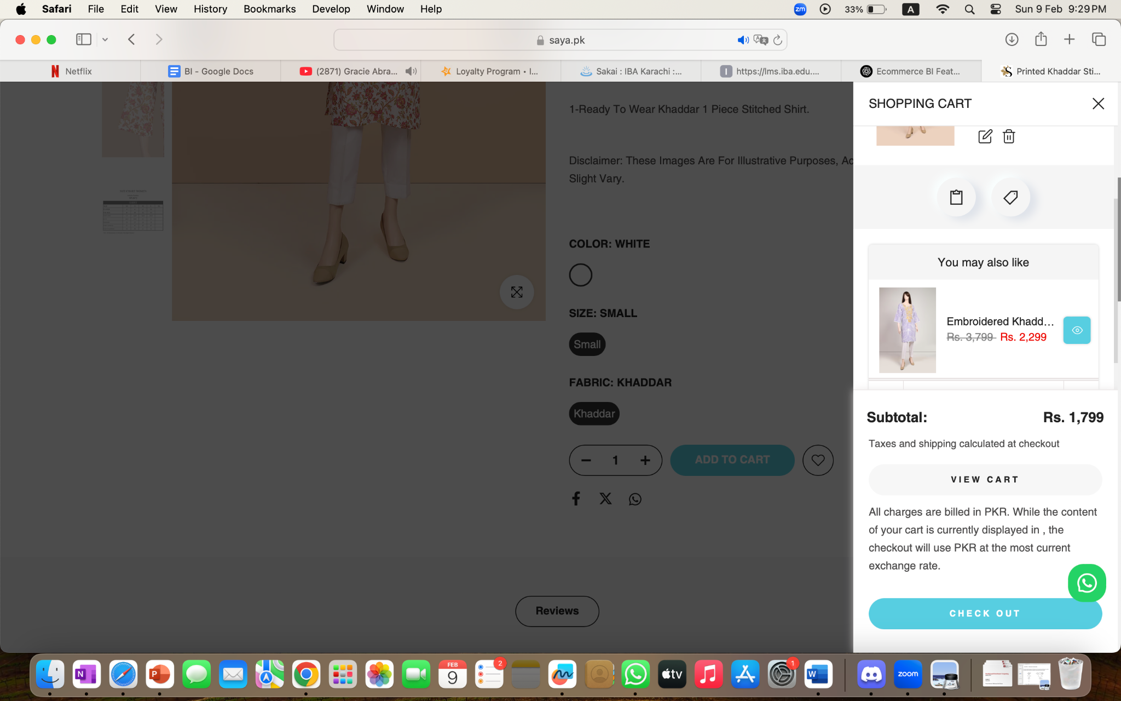

**You May Also Like**

leverages recommendation algorithms to suggest items based on user preferences, browsing history, and trending dishes, ultimately increasing order value and enhancing user experience.

* **Recently Viewed Products** –
  + The store tracks the last seen items and displays them, allowing users to quickly return to their preferred choices.
* **You May Also Like** –
  + Based on browsing history, Saya suggests similar products, such as matching dupattas or trousers when viewing a kurta.
* **Personalized Homepage** –
  + Returning users see curated collections, featuring items based on past purchases or searches.

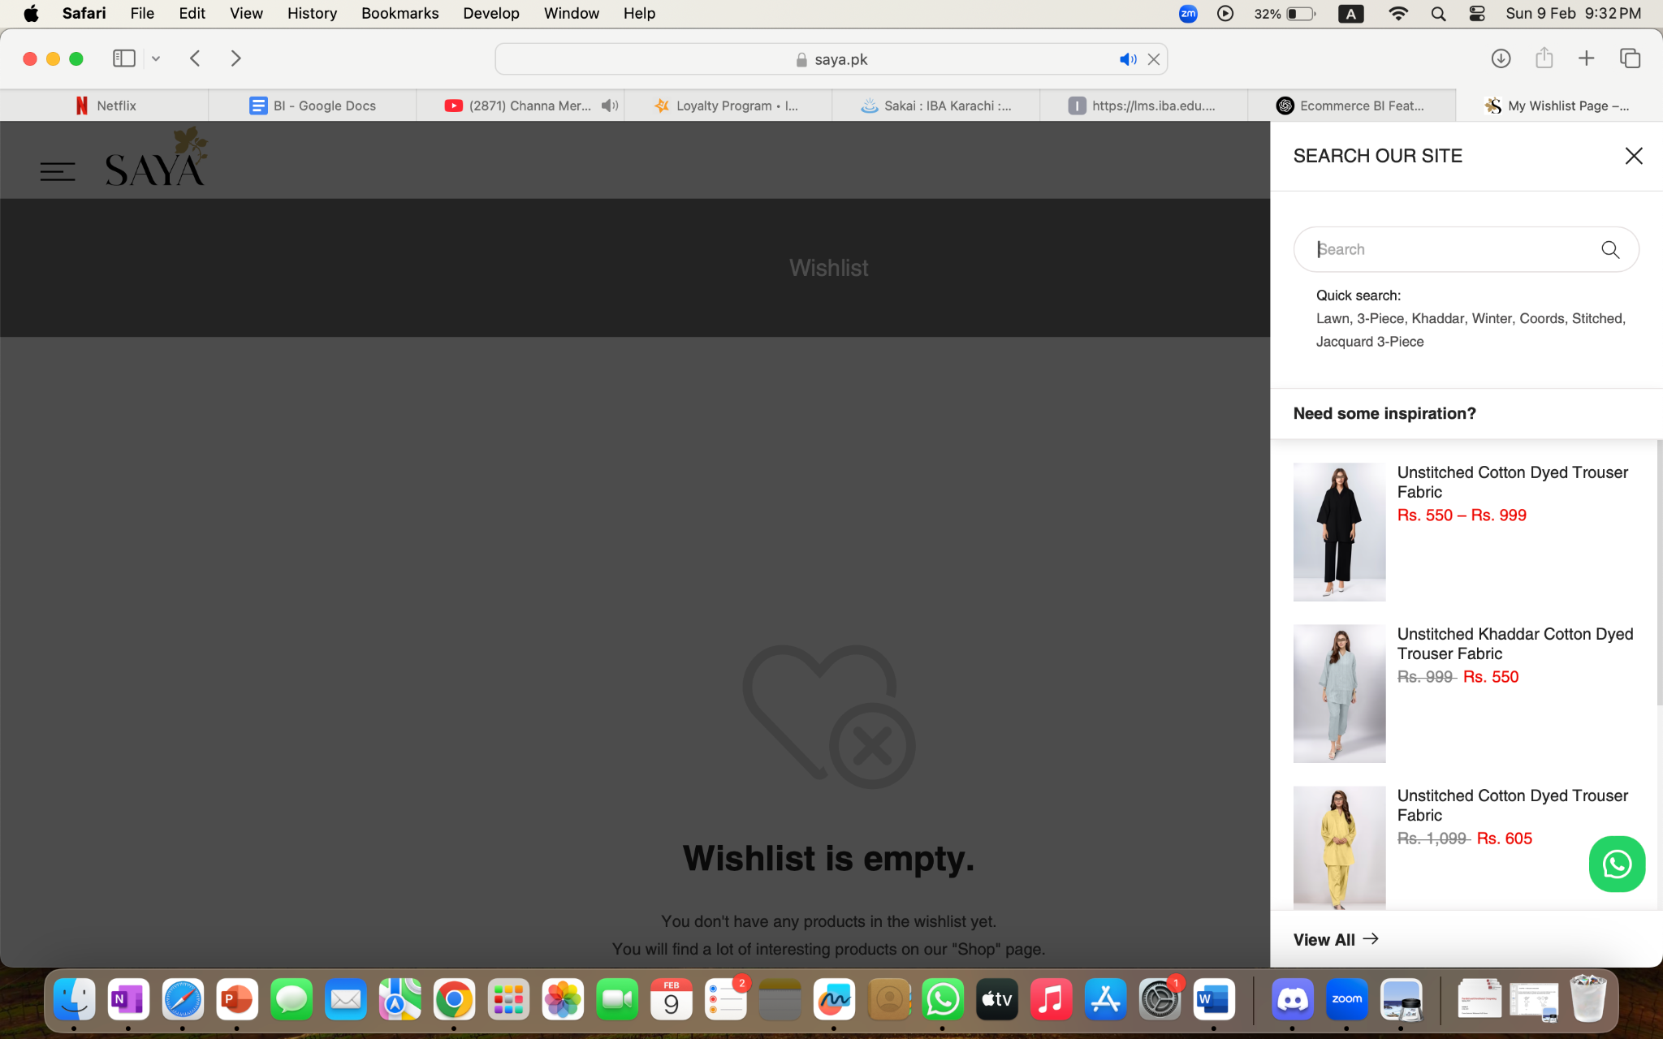

**Personalized Homepage**

Returning users see curated collections, featuring items based on past purchases or searches. Based on browsing history, Saya suggests similar products, such as matching dupattas or trousers when viewing a kurta.

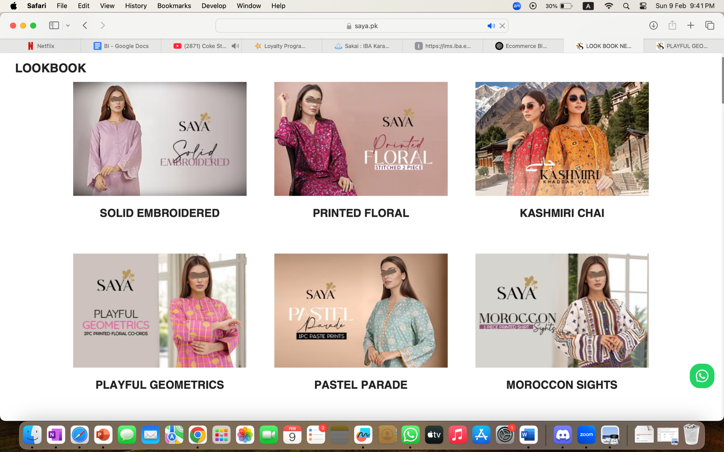

**Lookbooks**

Saya organizes its catalog into categories such as Summer Collection, Lawn, Unstitched, Ready-to-Wear, making it easy to navigate.

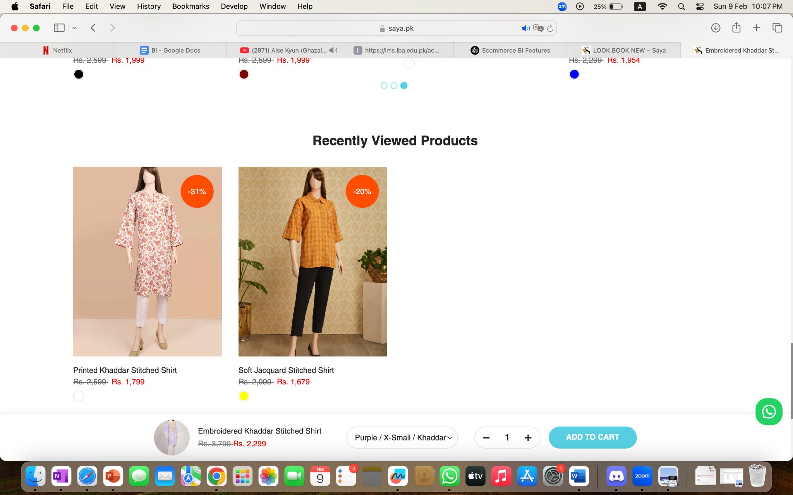

**Recently Viewed Products**

The store tracks the last seen items and displays them, allowing users to quickly return to their preferred choices.

### Search Filters & Sorting Options

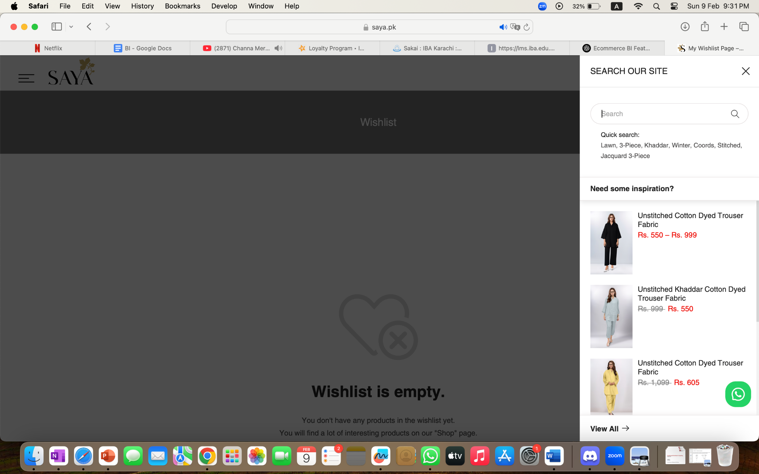

**Quick Search**

As users type in the search bar, Saya provides instant suggestions for product categories, colors, and styles, making it easier to find items quickly.

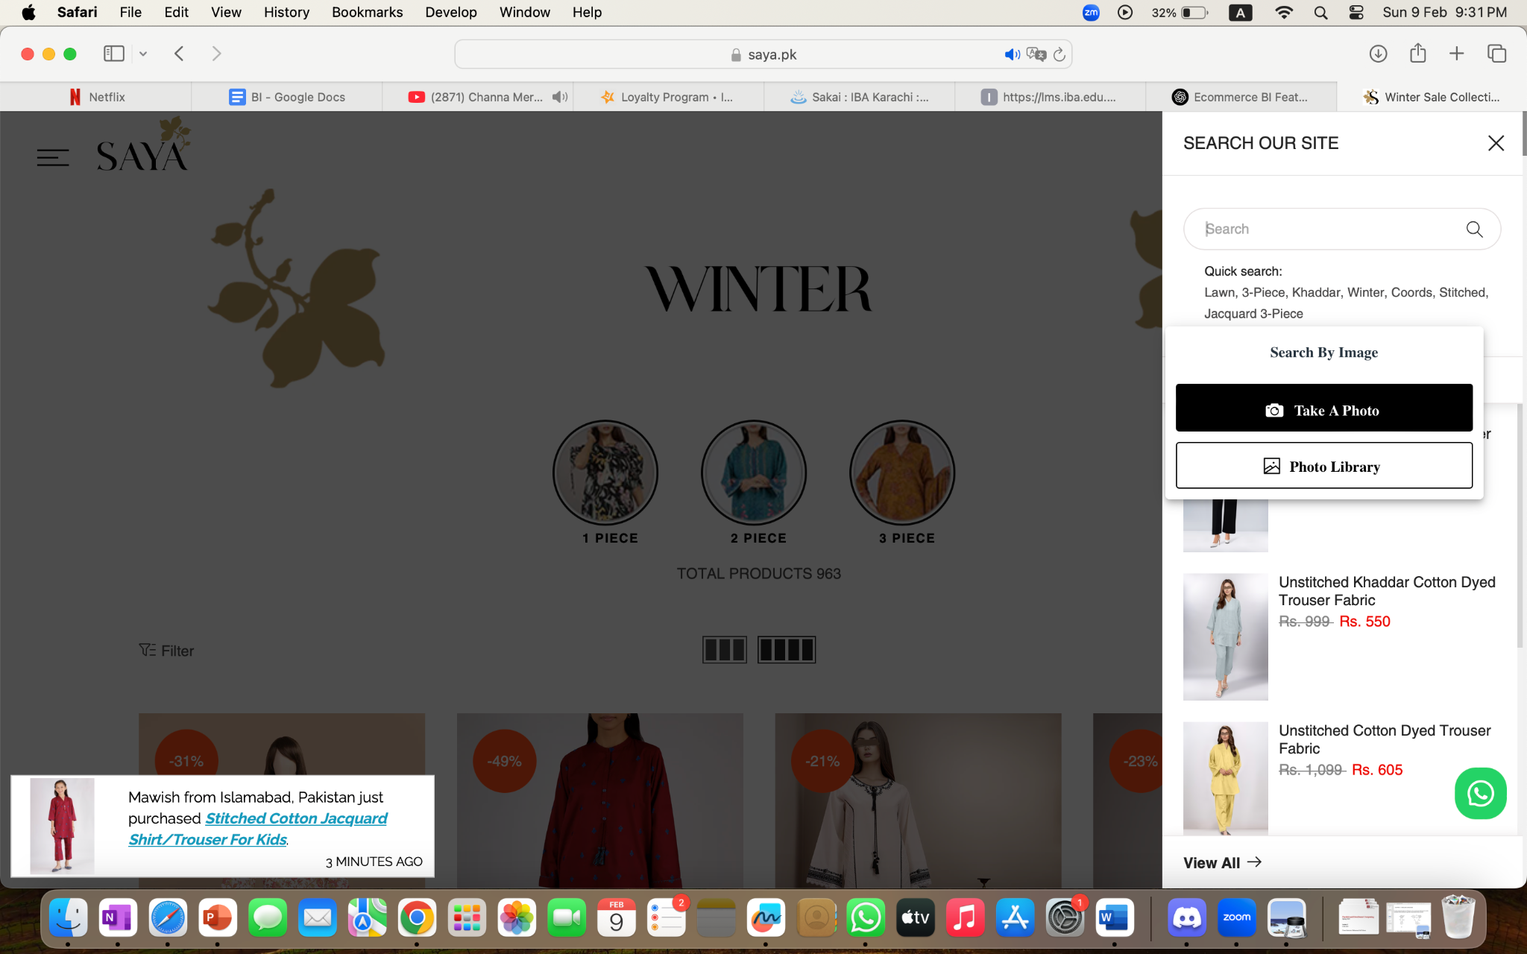

**Advanced Filters (Image Search)**

Users can upload a picture of an outfit they like, and Saya’s system suggests similar styles from its catalog using AI-powered image recognition.

* **Category-Based Filtering (Lookbooks)** –
  + Saya organizes its catalog into categories such as **Summer Collection, Lawn, Unstitched, Ready-to-Wear**, making it easy to navigate.
* **Fabric Type & Price Filters** –
  + Users can refine their search based on **material (Cotton, Lawn, Linen, Silk)** or price range to match their budget.
* **New Arrivals & Bestsellers** –
  + Filters allow shoppers to view **latest collections** or **top-selling products**, helping them stay updated with trends.

### Product Dashboards

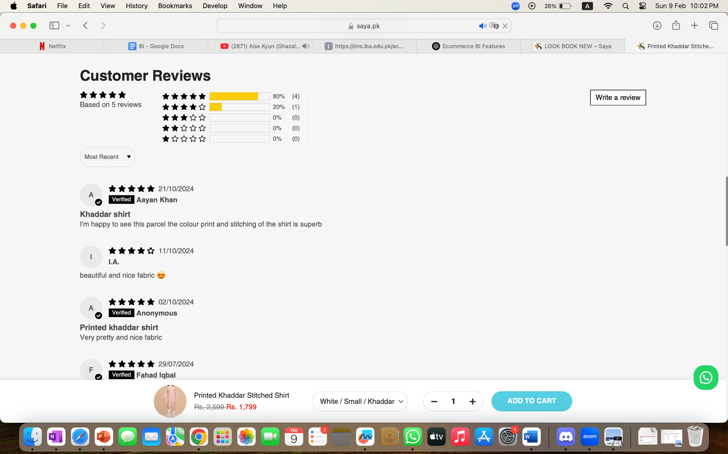

**Customer Reviews & Ratings**

Each product has a star rating and customer reviews, helping shoppers make informed decisions.

* **Customer Reviews & Ratings –** 
  + Each product has a star rating and customer reviews, helping shoppers make informed decisions.
* **Photo Reviews –** 
  + Buyers can upload images with their reviews, showcasing the real look of the product.
* **Q&A Section –** 
  + Some products feature a Q&A section, allowing customers to ask questions before purchasing.

### Dynamic Pricing and Promotions

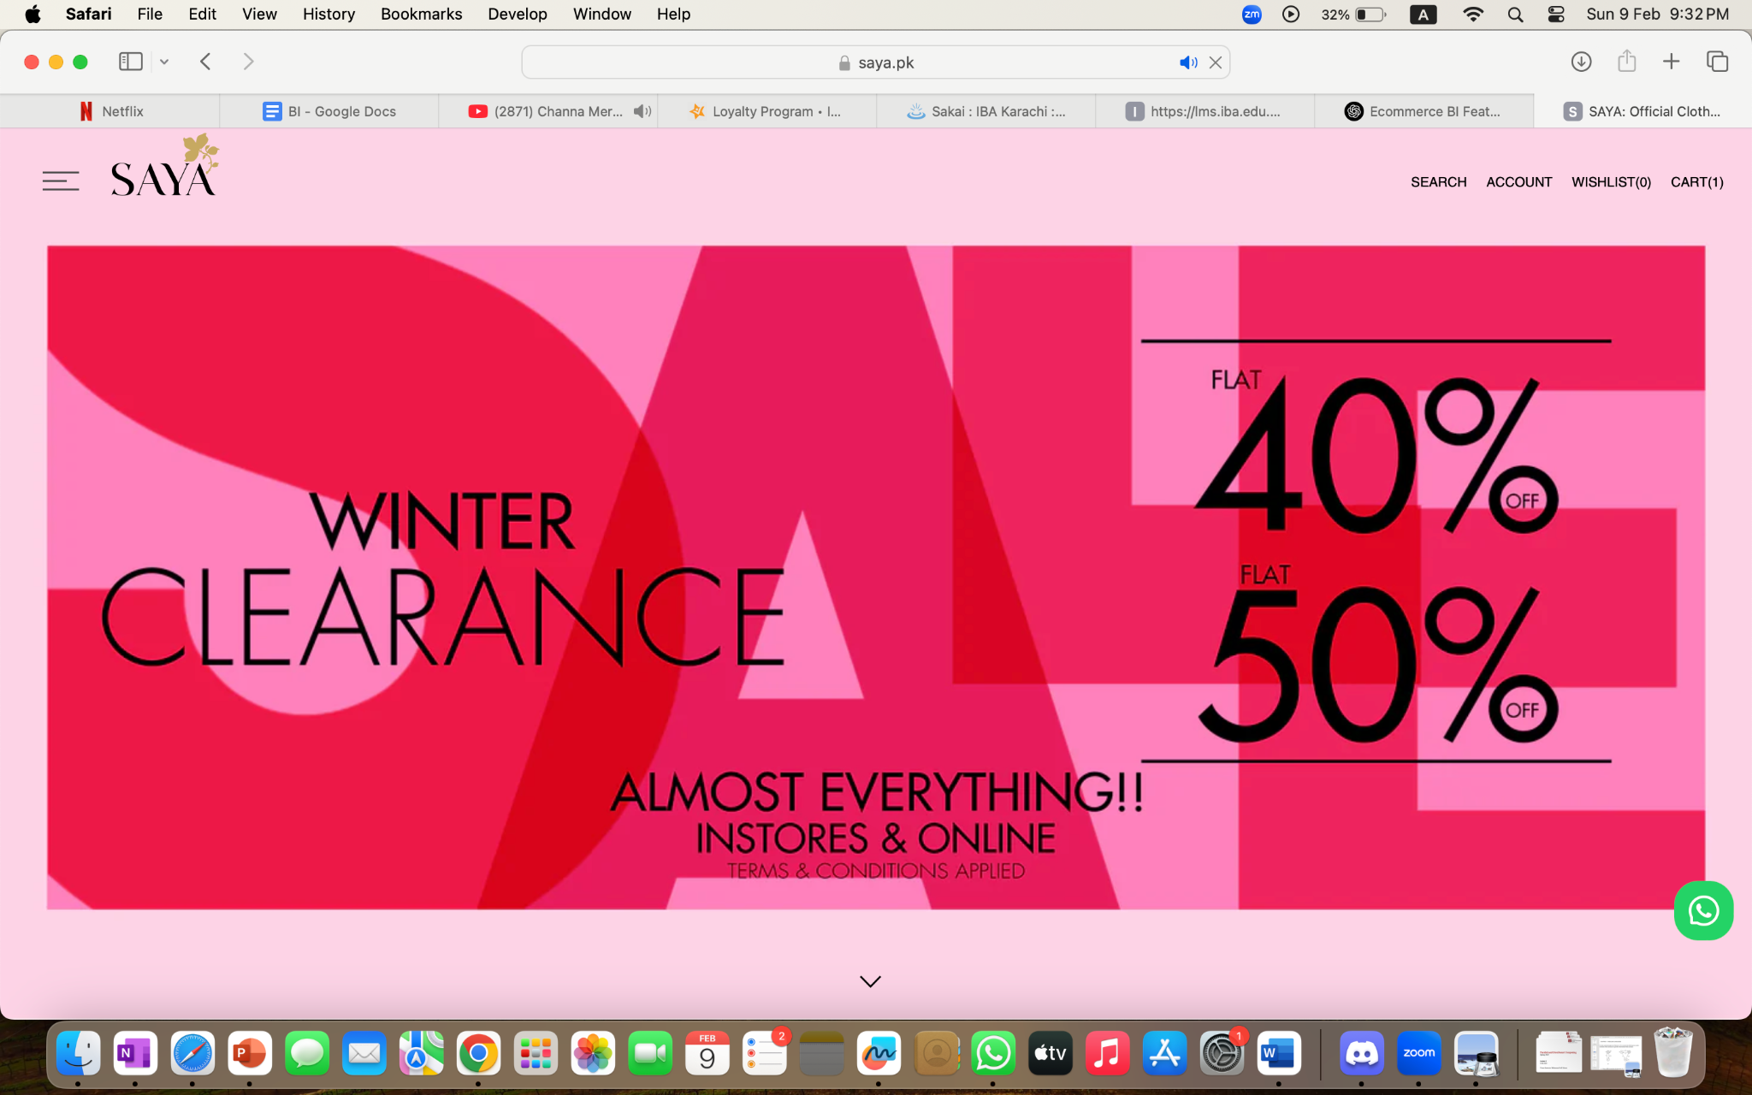

* **Limited-Time Discounts –** 
  + Flash sales are marked with a countdown timer (e.g., "20% Off for 24 Hours"), encouraging urgency.
* **Seasonal Sales & Festive Promotions –** 
  + Special discounts on Eid, Wedding Season, and Summer Sales are BI-driven to match peak buying trends.
* **Bundle Discounts –** 
  + Offers like "Buy 3, Get 1 Free" increase average order value.
* **Personalized Discount Codes –** 
  + Users who haven’t shopped in a while receive an email/SMS voucher (e.g., "Come Back & Get 10% Off!").

### Inventory Indicators

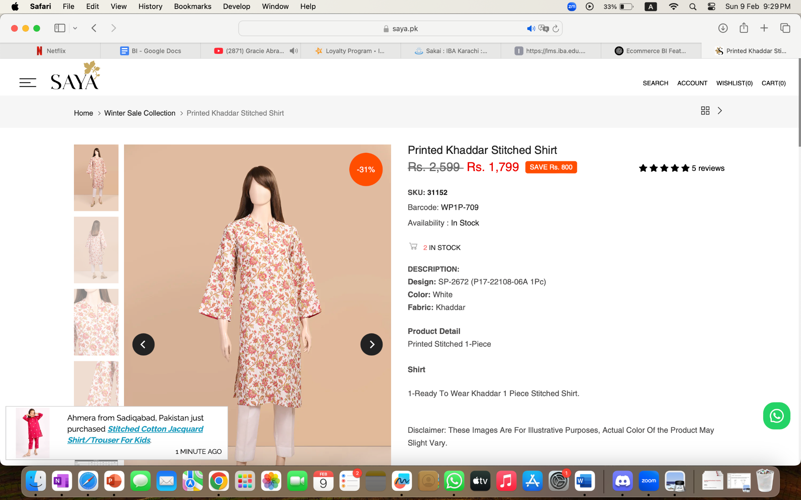

* **Low Stock Alerts –** 
  + Items show "Only 2 Left in Stock", pushing users to purchase quickly.
* **Out-of-Stock & Restock Notifications –** 
  + Users can sign up for "Notify Me When Available", allowing Saya to track demand and adjust inventory.
* **Size Availability Tracking –** 
  + If a small size is out of stock but medium is available, the system highlights alternative options.

### Others

**Checkout & Cart Optimization**

* **Abandoned Cart Reminders** –
  + If a customer adds items but doesn’t checkout, Saya sends an email/SMS reminding them to complete the purchase.
* **"Frequently Bought Together" Recommendations** –
  + If buying an unstitched suit, the system might suggest matching dupattas or accessories.
* **Preferred Payment Method Suggestions** –
  + If a user frequently pays via JazzCash or COD, the system highlights that option first.

**Customer Loyalty & Engagement**

* **Saya Reward Points & Membership** –
  + Customers earn points for every purchase, which can be redeemed for discounts.
* **Top 100 Products List** –
  + A section featuring the most purchased and best-rated items helps new customers choose trendy outfits.
* **Email & SMS Promotions** –
  + Saya sends personalized emails with exclusive deals, restock alerts, and new arrivals.

**Location & Delivery Optimization**

* **Geo-Based Delivery Estimates** –
  + The system calculates delivery time based on user location and warehouse stock availability.
* **Multiple Payment & Delivery Options** –
  + Saya offers Cash on Delivery (COD), Card Payments, and Wallets (EasyPaisa/JazzCash) for convenience.
* **Click & Collect Option** –
  + Some items allow pickup from nearby Saya outlets, bridging online and offline shopping.

# Task 2

Contrast the identified BI features with traditional retail practices:

* Traditional vs. Digital shopping experiences
* Layouts of stores like Imtiaz/Naheed/Carrefour
* Differences with Kiryana (local) stores
* Seasonal changes affecting shopping behavior
* Customer purchasing patterns



|  |  |
| --- | --- |
| **Traditional Retail** | **FoodPanda** |
| Recommendations would be generic, based on in-store promotions or sales person suggestions | Personalized recommendation tailored to every user based on past browsing and purchase history |
| Upselling and cross-selling is manual, with it depending on the cashier/salesperson. | Frequently Ordered Together / You May Also Like suggests relevant items at checkout (e.g., drinks with a burger), increasing basket size. |
| Cannot remember customer’s past orders | Enables quick reordering, reducing friction in repeat purchases |
| Seasonal recommendations based on in store shelf placement. | Trending & Seasonal Recommendations promote Cricket Deals, Iftar bundles, and winter comfort food based on real-time demand. Easy to switch deals. |
| Customers physically browse shelves or ask employees for product locations. | Smart Search & Auto-Suggestions: Instantly displays relevant results as users type |
| Searching for specific brands, products, or deals is time-consuming. | AI-Powered Best Match Sorting: Prioritizes restaurants based on popularity, delivery time, and order history. |
| Customers rely on word-of-mouth or limited in-store reviews | Advanced Filters: Enables sorting by cuisine, price range, dietary preferences, etc |
| Best-selling products are identified through sales records but without real-time insights. | Customer Ratings & Reviews: Immediate access to peer feedback on restaurants and dishes |
| Feedback loops are slow, requiring manual surveys or complaints. | Top Positive & Negative Feedback Highlights: Summarizes key insights, helping customers make informed choices. |
| Prices are static, with occasional sales or discount stickers | Menu Optimization: Identifies underperforming items for removal or promotion |
| Promotions apply to all customers equally, without personalization. | Best Seller Tags & Cuisine Categories: Highlights trending and highly rated dishes. |
| Weather, demand surges, or competitor pricing changes are not factored into pricing. | Flash Sales & Limited-Time Offers: Encourages impulse purchases |
| Popular items may go out of stock due to poor demand forecasting | Real-Time Price Adjustments: Delivery fees increase during peak demand (e.g., rain or rush hours) |
| Stock tracking is manual, with delays in updating availability. | Personalized Discounts: Special deals for returning users or inactive customers (churn prediction) |
| Overstocking leads to storage costs and waste | Competitor-Based Pricing Alerts: Adjusts prices dynamically to match industry trends. |
| Customer foot traffic is unpredictable and location-dependent | Cloud Kitchen Optimization: Identifies high-demand areas for virtual kitchens |
| Limited data on regional preferences without manual surveys. | Demand Forecasting: Predicts future trends, helping restaurants manage supply. |



|  |  |  |
| --- | --- | --- |
| **Feature** | **Traditional Retail (Physical Stores)** | **Saya** |
| **Personalized Recommendations** | Sales assistants provide suggestions based on customer queries. | AI-based recommendations show recently viewed products, bestsellers, and "You May Also Like" items. |
| **Search & Filters** | Customers browse racks manually. | Quick search, category filters, and image search streamline product discovery. |
| **Reviews & Ratings** | Word-of-mouth and in-store staff guidance. | Users check product ratings, customer reviews, and image reviews before purchasing. |
| **Dynamic Pricing & Promotions** | Discounts depend on seasonal sales and in-store promotions. | Flash sales, personalized discounts, and automated promotions based on demand. |
| **Inventory Tracking** | Stock availability is not always visible; customers must ask staff. | Real-time inventory updates, "Only 2 Left in Stock" alerts, and restock notifications. |
| **Checkout & Cart Optimization** | Customers physically carry products to checkout. | Digital carts with "Frequently Bought Together" suggestions and abandoned cart reminders. |
| **Delivery & Availability** | Customers must visit the store to check stock and buy. | Geo-based delivery estimates and multiple shipping options, including Click & Collect. |

**Key Differences:**

* Traditional retail is limited by physical space and relies on in-person interactions, whereas Saya Clothing uses AI-powered BI to provide a more convenient and data-driven shopping experience.
* In physical stores, product discovery is slower, while online platforms use search filters and AI recommendations to show relevant products instantly.
* Retail stores run seasonal discounts, but Saya adjusts prices dynamically based on demand, location, and customer behavior.

# **Overall benefits of having BI**

* Higher Average Order Value: Personalized recommendations encourage additional purchases.
* Improved Customer Retention: Customized experiences keep users engaged.
* Reduced Marketing Costs: Automated personalization minimizes the need for broad, ineffective promotions.
* Faster Decision-Making: Customers find what they need instantly.
* Higher Conversion Rates: AI-driven sorting ensures users see the best options first.
* Reduced Cart Abandonment: Efficient search prevents frustration and drop-offs.
* Improved Product Selection: Restaurants refine menus based on real-time demand.
* Enhanced Customer Trust: Ratings and reviews reduce hesitation, increasing sales.
* Reduced Inventory Waste: Eliminating low-performing items prevents losses
* Maximized Revenue: Dynamic pricing capitalizes on peak demand
* Higher Sales Volume: Flash deals create urgency, boosting conversions
* Better Customer Retention: Targeted promotions reduce customer churn
* Reduced Stockouts: Real-time tracking ensures consistent availability
* Lower Storage Costs: Restaurants optimize procurement based on demand forecasts
* Efficient Delivery Operations: AI-powered delivery heatmaps improve resource allocation
* Increased Repeat Orders: Rewards and memberships drive long-term engagement.
* Faster Market Expansion: Data-driven insights help restaurants open in the right areas

# Task 3

Reflect as a group on the following questions:

* Why are these recommendations shown to customers?
* How does the system know when to send notifications?
* What types of data are collected by the platform?
* Why do prices change dynamically?

# **FOODPANDA**



### Why are these recommendations shown to customers?

These recommendations are shown to customers to enhance user experience, increase sales, and improve operational efficiency.

1. **Increase Basket Size & Revenue (Upselling & Cross-Selling):**

* Encourages customers to add complementary items (e.g., fries with a burger, drinks with pizza, If a user orders biryani, Foodpanda may recommend raita or a cold drink.).
* Increases average order value without making customers feel pressured.
* Suggests items that go well together based on past orders and popular combos.
* Helps customers make faster decisions, reducing time spent browsing.

1. **Enhance Customer Convenience & Retention**

* Allows quick reordering of favorite meals with a single click.
* Creates a seamless experience by reducing the need to search from scratch
* If a user frequently orders from KFC, Foodpanda places it at the top of their homepage

1. Drive Customer Engagement & Seasonal Promotion
2. Optimize Pricing & Drive Conversions

* **For Customers:** 
  + Faster ordering, better recommendations, and a seamless experience.
* **For Restaurants:** 
  + Increased sales, optimized menus, and better inventory management.
* **For Foodpanda:** 
  + Higher revenue, improved customer retention, and stronger market dominance.

### How does the system know when to send notifications?

Foodpanda uses data analytics and user behavior tracking to determine the best times for sending notifications. The platform collects and analyzes real-time data, including:

|  |  |
| --- | --- |
| **Trigger** | **Notification Example in Foodpanda** |
| **Inactivity Detection** | If a user hasn’t ordered in a while, Foodpanda sends a "We Miss You! Here's 20% Off" voucher. |
| **Time-Based Deals** | At midnight, users might get notifications for "Late Night Deals - Order Now!" |
| **Cart Abandonment** | If a user adds food to the cart but doesn’t complete the purchase, they receive a reminder notification. |
| **Location-Based Offers** | If a user is near a partner restaurant, Foodpanda may send "Exclusive Deal Near You!" alerts. |
| **Order Status Updates** | Users receive notifications when the restaurant confirms the order, dispatches it, and when the rider is arriving. |
| **Popular & Trending Items** | If a dish is selling out fast, users may get "Hurry! Only a Few Left of Your Favorite Biryani". |

These notifications increase engagement, reduce cart abandonment, and boost sales through targeted marketing.

### What types of data are collected by the platform?

Foodpanda collects a vast range of structured and unstructured data to personalize the user experience and optimize operations.

|  |  |
| --- | --- |
| **Data Type** | **Examples in Foodpanda** |
| **User Behavior Data** | Search history, past orders, cart items, frequently visited restaurants. |
| **Time & Location Data** | Peak ordering hours, GPS location, nearby restaurants. |
| **Demographic Data** | User’s age, preferences, payment method history. |
| **Device & App Usage** | Type of device, session duration, app version. |
| **Engagement Metrics** | Click-through rates on promotions, interaction with recommendations. |
| **Restaurant Data** | Order volume, popular dishes, average delivery time. |
| **Delivery & Logistics** | Rider availability, real-time delivery tracking, estimated time of arrival. |

This data is used to improve:

* **Personalized recommendations** (suggesting preferred dishes/restaurants).
* **Dynamic pricing and promotions** (offering deals based on order history).
* **Delivery efficiency** (optimizing rider routes based on traffic and demand).

### Why do prices change dynamically?

Foodpanda uses Dynamic Pricing Algorithms that adjust prices based on demand, restaurant popularity, time, and competition.

|  |  |
| --- | --- |
| **Factor** | **Example in Foodpanda** |
| **Time-Based Demand** | During lunch or dinner rush hours, delivery fees increase due to high demand. |
| **Weather Conditions** | On rainy days, delivery charges rise due to limited rider availability. |
| **Restaurant Popularity** | High-demand restaurants may have higher delivery charges than less popular ones. |
| **Competitor Adjustments** | If McDonald's lowers the price of a burger, competing fast-food chains might adjust their prices accordingly. |
| **User Behavior** | If a user frequently orders from a specific restaurant, the system may recommend similar places but at slightly lower prices. |
| **Limited-Time Offers** | Flash sales and "Order Now! 20% Off for the Next 30 Mins" create urgency. |

This pricing model maximizes revenue for Foodpanda, benefits restaurant partners, and ensures better rider incentives.

# **SAYA**



### Why are these recommendations shown to customers in Saya Clothing?

Saya Clothing uses AI-driven recommendations to enhance customer experience, increase sales, and improve engagement. These recommendations are based on customer behavior, trends, and sales data to ensure the most relevant products are displayed.

|  |  |  |
| --- | --- | --- |
| **Type of Recommendation** | **Reason for Showing** | **Example in Saya Clothing** |
| **Recently Viewed** | Encourages customers to revisit products they were interested in. | "You recently viewed this embroidered kurta – it's still available in your size!" |
| **Bestsellers & Trending** | Highlights popular products to create trust and urgency. | "This lawn suit is selling fast – Order before it’s out of stock!" |
| **"You May Also Like" Suggestions** | Uses past purchases and browsing history to suggest similar items. | "If you liked this printed kurti, you might love this new arrival!" |
| **Seasonal & Event-Based** | Aligns promotions with current demand (Eid, winter, wedding season). | "Get cozy! New winter shawls and pashminas are now available." |
| **Cart-Based Upselling & Bundling** | Encourages customers to add more items by offering complementary products. | "Complete your look! Pair this lawn dress with our matching dupatta and trousers." |
| **Personalized Discounts** | Retargets customers who have abandoned carts or are frequent buyers. | "Welcome back! Get 10% off your next order as a thank-you for shopping with us." |

* **Increases Sales & Conversions** –
  + Personalized suggestions boost purchase likelihood by showing items the user is more likely to buy.
* **Enhances Customer Experience** –
  + Saves users time by curating options based on their preferences.
* **Reduces Cart Abandonment** –
  + Recommending similar or discounted alternatives helps convert hesitant buyers.
* **Encourages Repeat Purchases** –
  + Keeps users engaged by reminding them of past interests and new arrivals.
* **Drives Seasonal & Promotional Sales** –
  + Aligns product visibility with festivals, weather, and shopping trends.

### How does the system know when to send notifications?

Saya Clothing uses user behavior tracking and AI-driven analytics to send targeted notifications at the right time.

|  |  |
| --- | --- |
| **Trigger** | **Notification Example in Saya Clothing** |
| **Cart Abandonment** | "Your cart is waiting! Complete your order now and get 10% off." |
| **Stock Availability** | "The lawn suit you viewed is back in stock – Order now before it sells out!" |
| **Flash Sales & Limited Offers** | "Hurry! Flat 20% Off on Summer Collection – Offer ends at midnight." |
| **New Arrivals & Trends** | "Latest Eid Collection is here! Be the first to shop exclusive designs." |
| **Price Drops** | "The kurta set you liked is now 15% cheaper – Shop now before prices go up!" |

### What types of data are collected by the platform?

|  |  |
| --- | --- |
| **Data Type** | **Example in Saya Clothing** |
| **User Behavior** | Browsing history, past purchases, cart additions. |
| **Search Data** | Search terms, filters used, image-based search history. |
| **Engagement Metrics** | Clicks on promotions, time spent on pages, interaction with recommended products. |
| **Location Data** | Delivery addresses, store visits for Click & Collect. |
| **Demographics** | Age, gender, preferred payment methods. |
| **Device & App Usage** | Mobile vs desktop usage, peak activity times. |

Saya Clothing leverages this data to improve personalization, marketing, and logistics, enhancing the customer experience.

### Why do prices change dynamically?

Saya Clothing adjusts prices based on demand, seasonality, and competitor analysis to maximize revenue and sales.

|  |  |
| --- | --- |
| **Factor** | **Example in Saya Clothing** |
| **Seasonal Demand** | Lawn suits are priced higher in summer and discounted in winter. |
| **Limited Stock** | "Only a few left!" items may have higher prices due to demand. |
| **Competitor Pricing** | If a competitor runs a sale, Saya may offer matching or better discounts. |
| **Flash Sales & Urgency** | "Limited Time Offer: 25% Off for the next 3 hours!" encourages quick purchases. |
| **Personalized Discounts** | Customers who frequently buy receive special promo codes via email/SMS. |